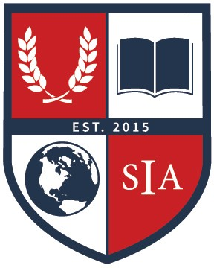
Spokane International Academy
777 E Magnesium Rd Spokane, WA 99208

Jordan Robinett, Nutrition Specialist
Email: robinett@spokaneintlacademy.org

Welcome Back from Spokane International Academy

Spokane International Academy is committed to providing nutritious meals to students to support their classroom learning and quality of life. We participate in the National School Breakfast and Lunch Program to ensure that students are offered well- balanced meals at affordable prices.
Here are a few helpful reminders,

- If you were previously approved through Spokane International Academy to receive meal benefits, they will be effective through October 17th, 2022. Once the meal benefits expire you will be charged full price for all meals consumed.

- If you receive a Notice of Eligibility letter from Spokane International Academy you do not need to fill out a meal application. Please make sure that all your students’ names are on the letter. If not, please call us at the number listed below.

- If you want to apply for meal benefits fill out the online meal application in Skyward Family Access. If you do not have online access you may complete the application at the school using one of our computers or you may ask for a paper application located in the main office. Please return all paper applications to the school.

- Notifications regarding any account balances that are equal to or less than $5.00 are made to parents/guardians weekly through one or more of these methods (email, mail, or phone calls) from the main office of Spokane International Academy.

- You can set up an account and make online payments through EFunds (link located on our webpage) or you can make check or cash payments in the main office.

- If you have any questions please call 509-209-8750 we are here to help.

- We participate in the USDA Breakfast and Lunch Program which means we serve Whole Grains, Lean Meats, Low Fat Dairy and tons of fruits and vegetables!

Spokane International Academy does not discriminate in any programs or activities on the basis of sex, race, creed, religion, color, national origin, honorably discharged veteran or military status, sexual orientation, gender expression, gender identity, the presence of any sensory, mental, or physical disability, or the use of a trained dog guide or service animal and provides equal access to the Boy Scouts and other designated youth groups. The following employee has been designated to handle questions and complaints of alleged discrimination: Civil Rights, Title IX, and Section 504 Coordinator: Jacqueline Pariseau, 509-209-8730, pariseau@spokaneintlacademy.org; Address: 777 E Magnesium Rd, Spokane, WA 99208

